**Commercial Tax-Invoice Whse. Report**

**Purchase Order:**

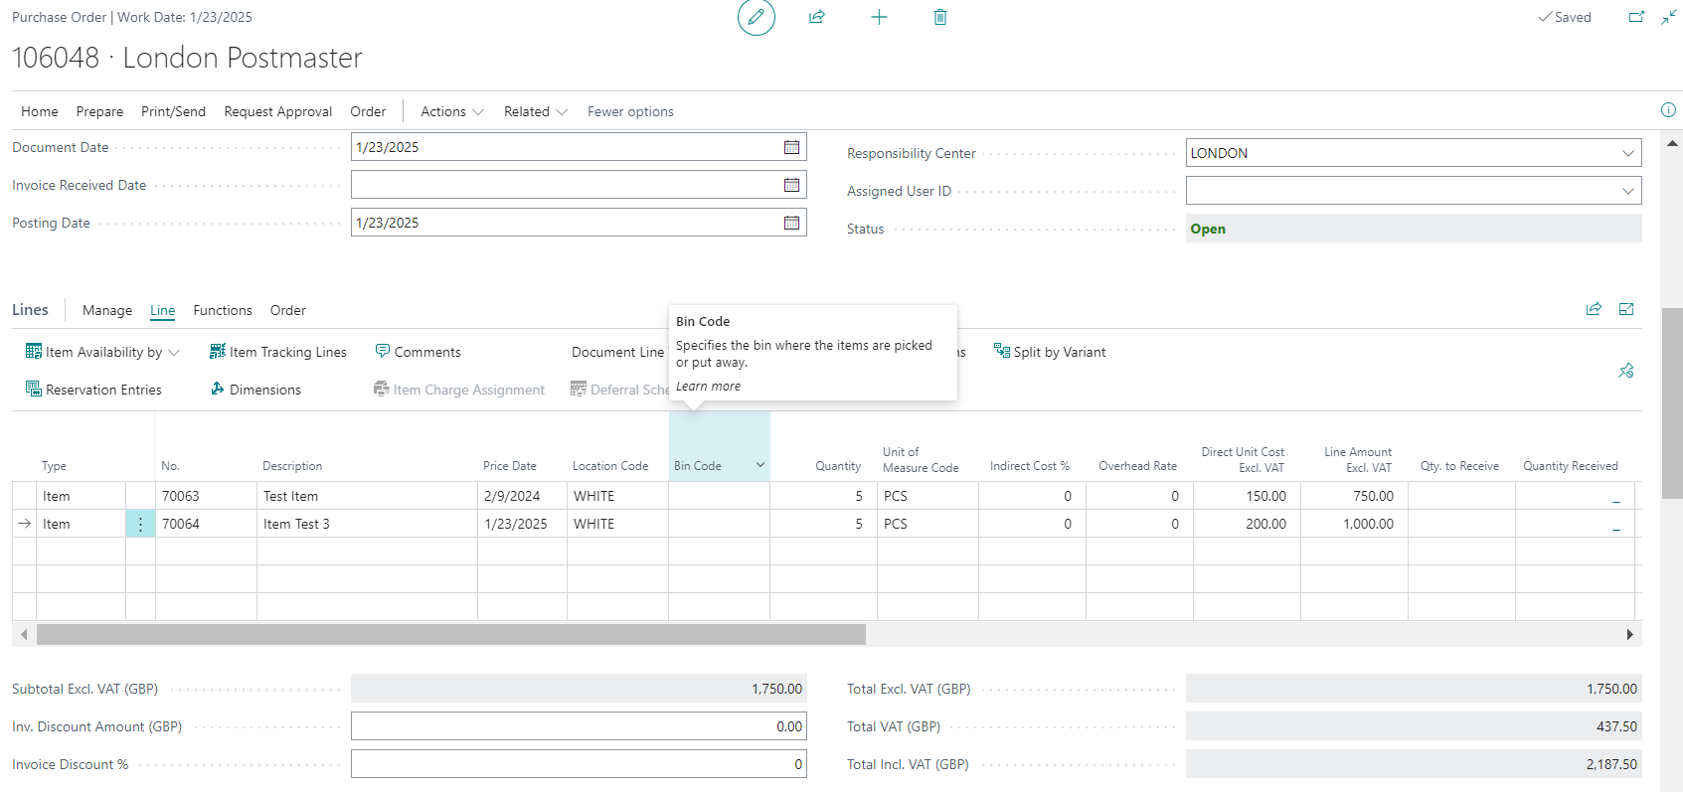

**Item Tracking 1:**

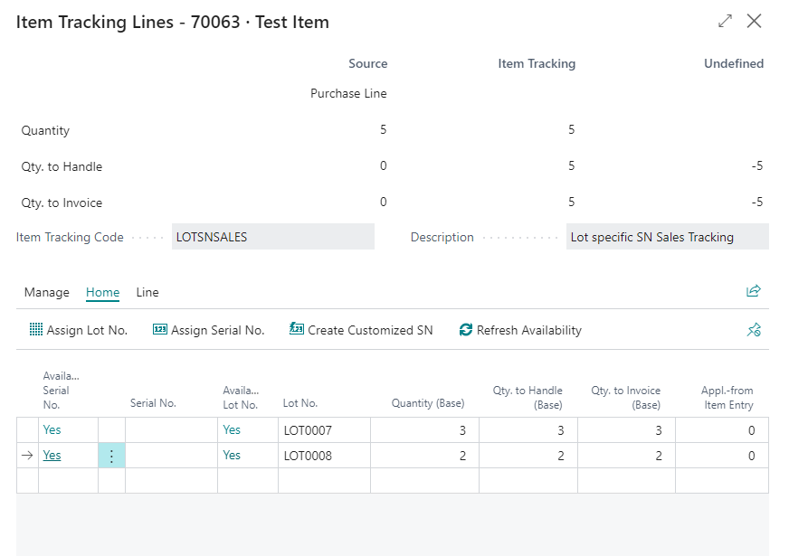

**Item Tracking Lines 2:**

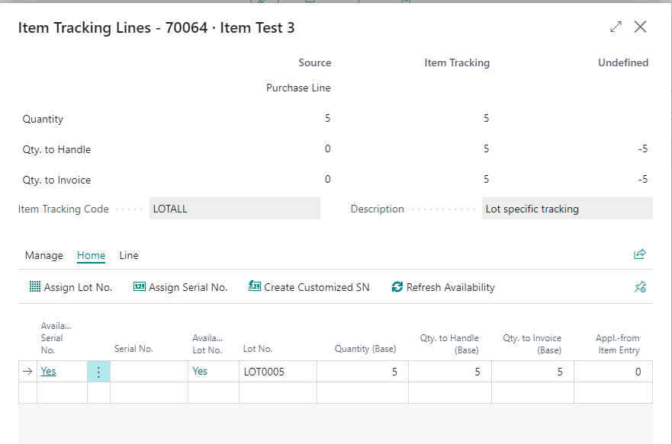

**Warehouse Receipt:**

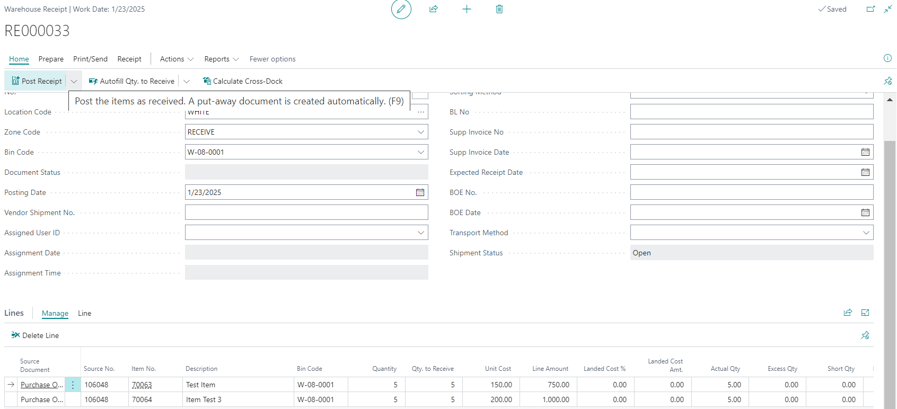

**Item tracking Line 1:**

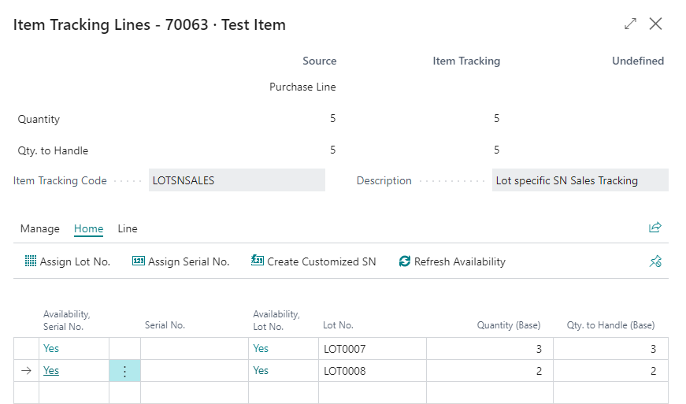

**Item Tracking Lines: 2**

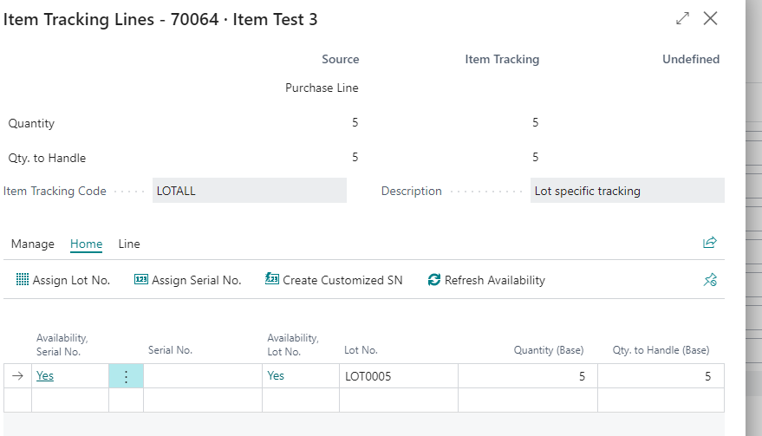

**Sales Order**

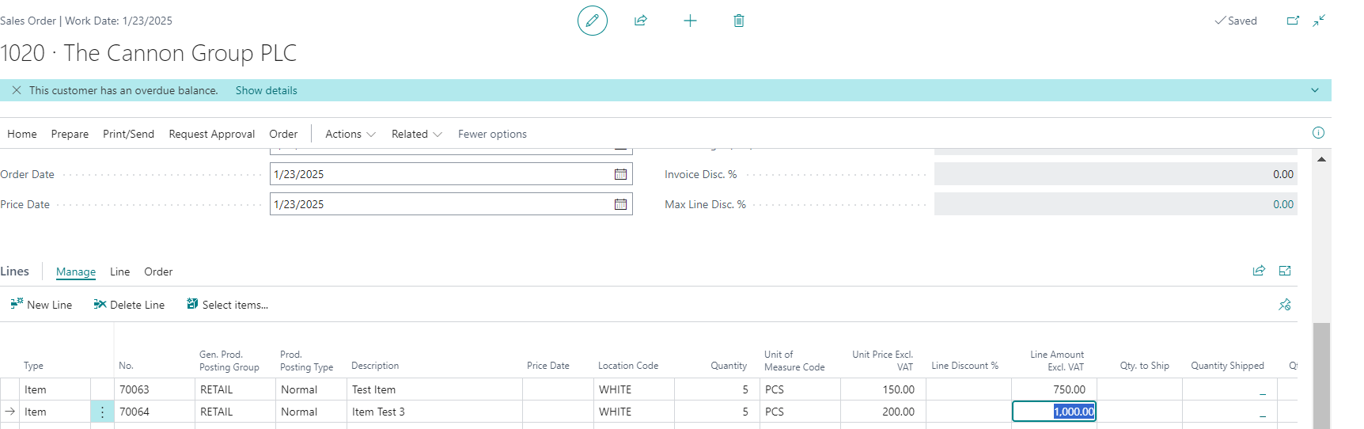

**Item Tracking 1:**

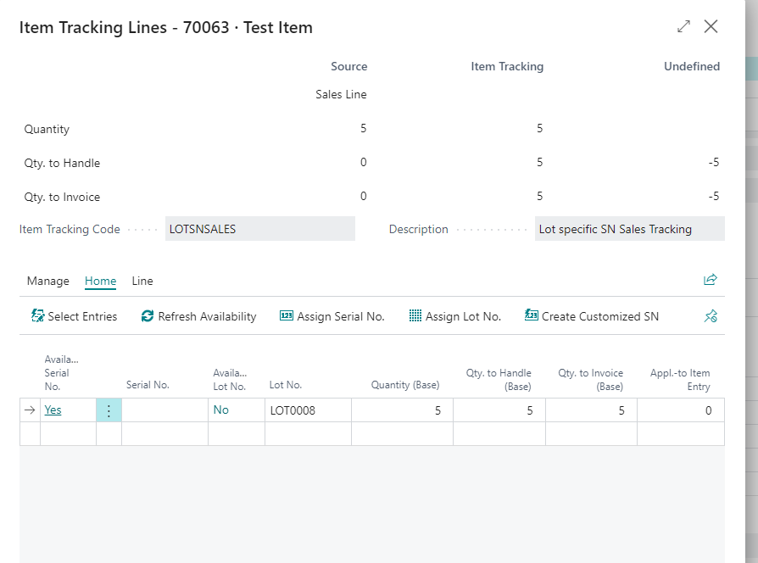

**Tracking 2:**

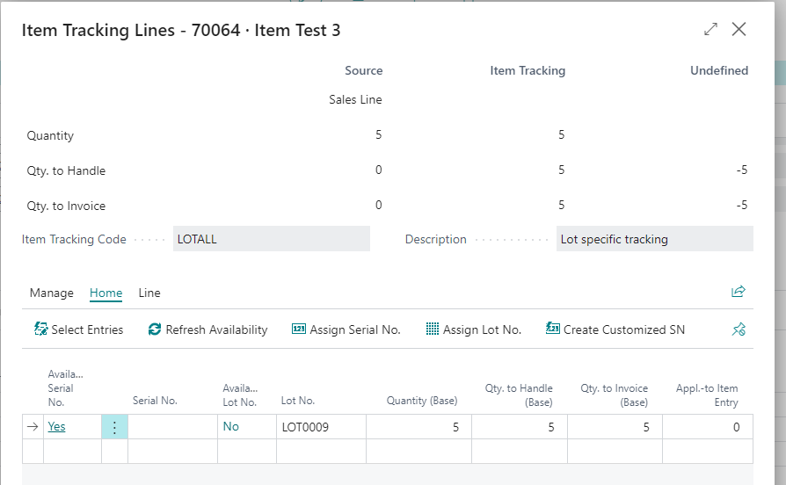

**Warehouse shipment :**

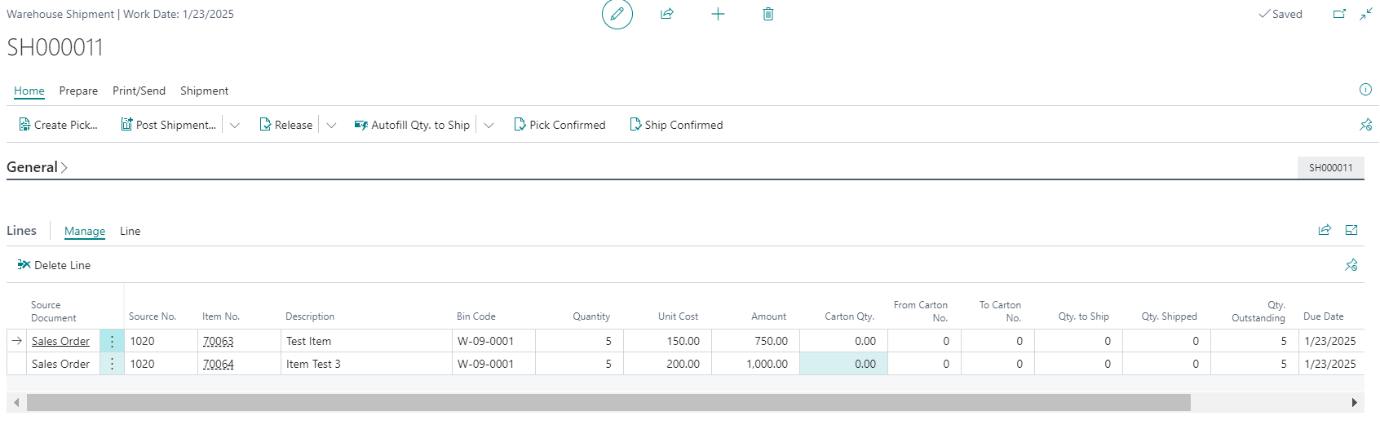

**Report Preview:**

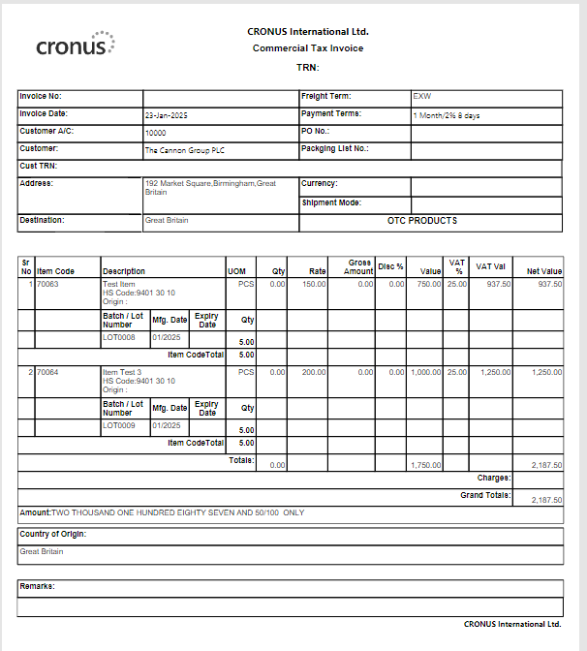

**2:**

